**Fundamentals of Software Engineering**

# **Project Title:** CuisineCraft ERP

**Subtitle**: Restaurant Enterprise Resource Planning, Desktop Application

|  |  |
| --- | --- |
| **Name** | **Roll Number** |
| Abdullah Maqsood | 22L-7478 |
| Bilal Ahmad | 22L-7472 |
| Shahzad Waris | 22L-7530 |
| Hafiz Hashir | 22L-7553 |

**Deliverable Number:** 1

**Date of Submission:** 25th March, 2024

**1. Project Title and Introduction:**

The CuisineCraft ERP aims to develop a comprehensive desktop application for managing various aspects of restaurant operations. This system will streamline processes related to customer relationship management (CRM), inventory management, and various other essential functions in a restaurant setting. Deliverable 1 focuses on the initial modules of the application, including Login, Home, CRM, and Inventory.

**2. User Stories:**

* **Module 1 (Login and Signup):**
  + As a user, I want to be able to create an account and log into the application using my credentials.
    - Sub-User Stories:
      * User should be able to select a username and password for his account.
      * User should be able to enter their username and password.
      * System should verify the entered credentials against the database.
      * User should receive appropriate feedback for successful or failed login attempts.
  + And I know I am done when I will be able to login into this application with my unique credentials.
* **Module 2 (Home):**
  + As a user, I want to have a central dashboard displaying key information and functionalities.
    - Sub-User Stories:
      * User should be greeted with a welcome message upon successful login.
      * Dashboard should display relevant statistics such as sales figures, orders etc.
      * Navigation options to other modules should be easily accessible.
  + And I know I am done when I can have a bird eye view of my Resturant.
* **Module 3 (CRM):**
  + As a restaurant manager, I want to efficiently manage customer relationships and feedback.
    - Sub-User Stories:
      * Ability to create and view customer profiles with details such as name, contact information, etc.
      * Record customer visits and associated details like date, time, and order.
      * Capture customer feedback and suggestions for improvement.
      * Implement a loyalty program to reward frequent customers.
  + And I know I am done when I can save the information of my customers and I have a data that shows the feedbacks provided by my customers.
* **Module 4 (Inventory):**
  + As a restaurant staff member, I want to manage stock items and track inventory levels.
    - Sub-User Stories:
      * Maintain a catalog of stock items with details like name, quantity, and unit price.
      * Record purchases of stock items including supplier information and quantities.
      * Generate alerts for low stock levels to facilitate timely reordering.
  + And I know I am done when I can update my inventory and gets the list of low stock items on a single click.

**3. Structured Specifications:**

* **Module 1:**
  + Specification: User Authentication
    - Description: The system shall authenticate users based on the provided username and password.
    - Acceptance Criteria:
      * Upon successful authentication, the user should be redirected to the home dashboard.
      * Incorrect credentials should prompt appropriate error messages.
  + Specification: Sign up option
    - Description: If the user has not been registered, they can sign up and create an account.
* **Module 2:**

Specification: Total Quantity

* Description: Text view that describes the total quantity of items, total customers and revenue.

Specification: Finance Overview

* Description: A graph that show the trends of restaurants finance.

Specification:

* Description: A graphical representation of number of items in menu per category.
* **Module 3:**
  + Specification: Record Customer Data
    - Description: All the customers’ data will be recorded and maintained properly in a database.
  + Specification: Record Visits Data
    - Description: On each customer visit, record the items ordered from the menu and the bill of the customer.
  + Specification: Record Feedback Data
    - Description: Record the feedback of the customers in a database table along with customer details like phone number or email.

Specification: Record Loyalty Data

* + - Description: Frequent customers are added into the membership/loyalty program. This data in maintained in a separate table in the Customer Database.
* **Module 4:**

Specification: Record Items

* Description: All information related to inventory items will be stored and updated in database. There will be also an option to delete a cretain item from inventory.

Specification: Record Suppliers

* Description: Information of Suppliers will be stored in database and easily accessible to owner. There will be option to add, update and delete the information of suppliers.

Specification: Low stock Alerts

* Description: A graph will show owner the name of items whose stock has decreased from a certain level.

Specification: Analysis

* Description: Graphs will inform the owner of the restaurant about the availability of items with respect to there category.

**4. Scrum Board:**

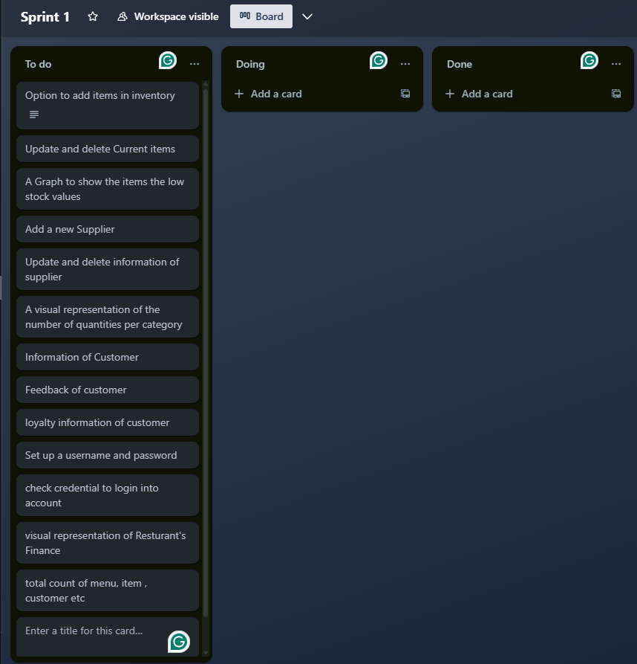

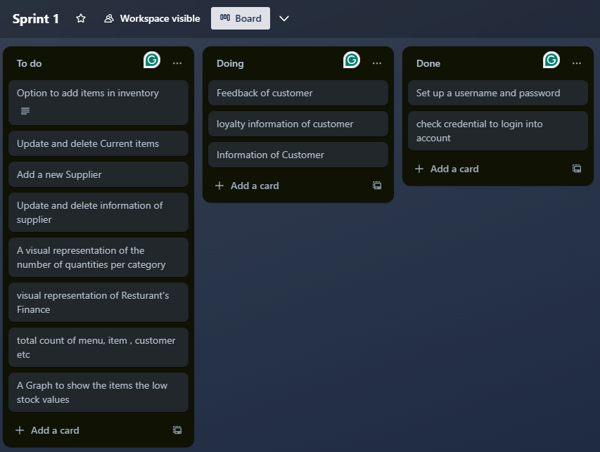

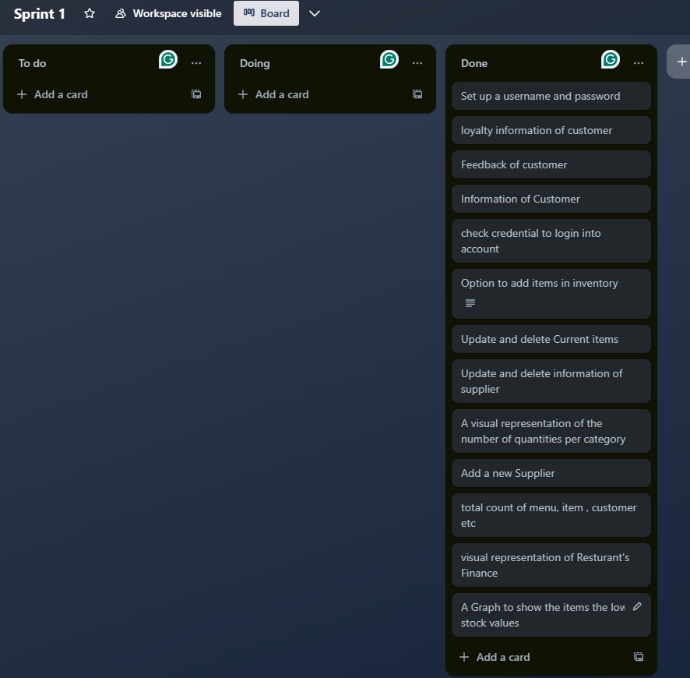

**5. NFR Specification:**

* **Performance:** The system should perform efficiently without delays in displaying data or performing operations.
* **Security:** User authentication and authorization should be implemented using UserName and Password verification.
* **Usability:** The user interface should be intuitive and easy to navigate, requiring minimal training for new users.
* **Reliability:** The system should have a system uptime of at least 99.9% and it should be capabale of data recovery from unexpected failures.
* **Maintainability:** The codebase should follow coding standards and best practices to facilitate easy maintenance and future enhancements.

**6. Iteration 1 Implementation Screenshots:**

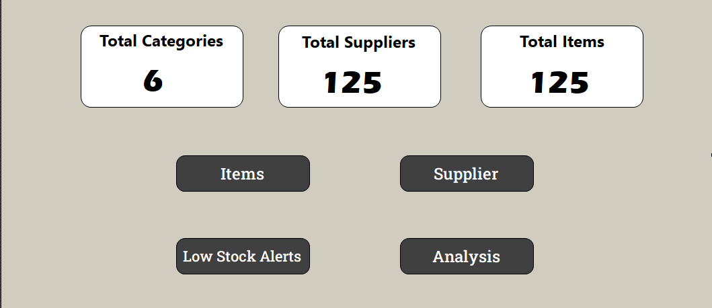 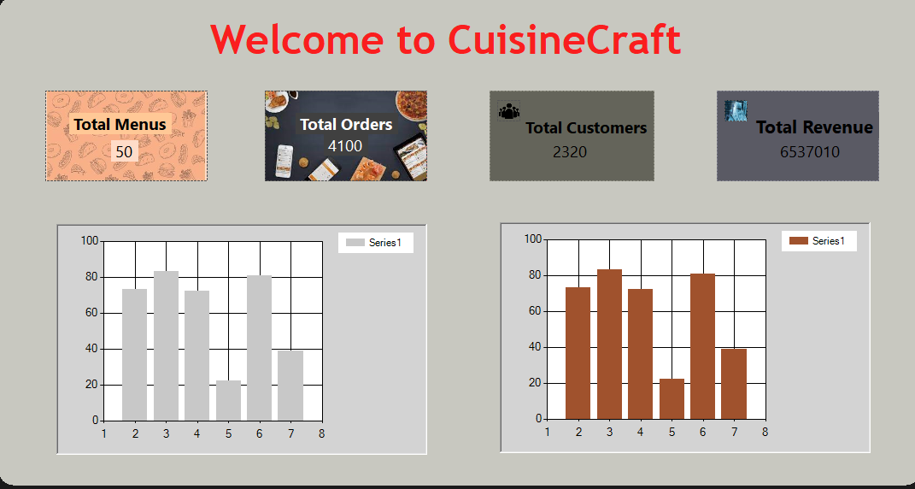

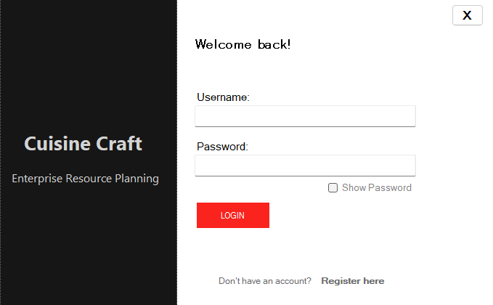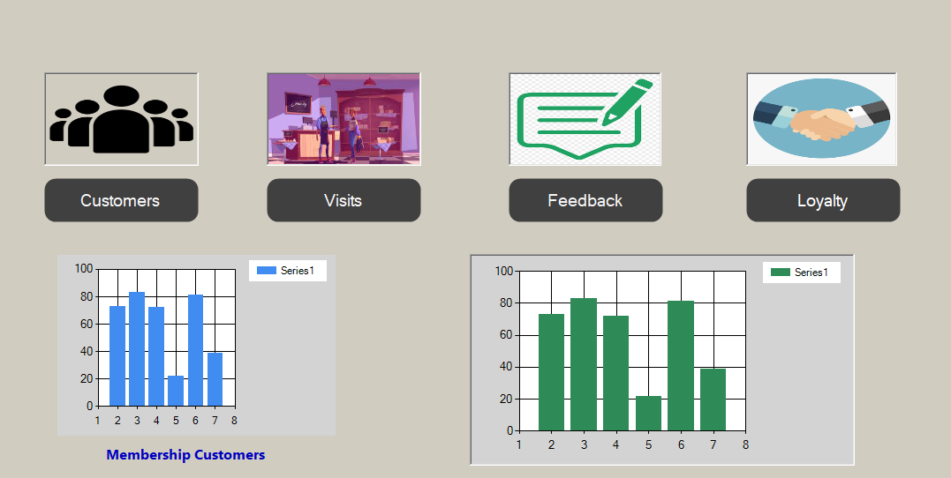

**7. Work Division:**

Module1: Hafiz Hashir

Module2: Bilal Ahmad

Module3: Abdullah Maqsood

Module4: Shahzad Waris